**Abstract**

This project aims to address the sales optimization and return reduction challenges faced by a skateboard company by developing an interactive analytics dashboard. By leveraging data-driven insights, the dashboard will empower the company to make informed decisions, identify regional trends, and enhance marketing strategies. Ultimately, this initiative seeks to boost sales and minimize returns, resulting in improved operational efficiency and profitability for the company.

**Acknowledgment**

We are highly grateful to Adv. Annasaheb D. Chavan Chairman, trustee & all Board of Directors Sant Gajanan Maharaj College of Engineering Mahagaon, for providing this opportunity to carry our major project phase-II work.

We are thankful to Dr. S. H. Sawant Principal, S.G.M.C.O.E Mahagaon for his encouragement and valuable guidance, I am/We are grateful for the help and support received from Head of Department Prof. S. G. Swami and Project Coordinator Asst. Prof. A. P. Narayankar and is acknowledged with reverential thanks.

We would like to express a deep sense of gratitude and thanks profusely to our Project Guide Prof. Swami S. G. without his wise counsel and guidance it would have been difficult to carryout project in this manner.

We express gratitude to other faculty members of department for their intellectual support throughout the course of this work, finally We are indebted to all whosoever have contributed in this project work.

**Abbreviations**

* BI : Business Intelligence
* KPI : Key Performance Indicator
* SQL : Structured Query Language
* ETL : Extract, Transform, Load
* CSV : Comma-Separated Values
* UI : User Interface
* UX : User Experience
* QA : Quality Assurance
* UAT : User Acceptance Testing
* GUI : Graphical User Interface
* ROI : Return on Investment

**Project Overview**

Project Title : Uncovering Industrial Trends by analysing data using Power BI

Academic Year : 2023-24

Institution : Sant Gajanan Maharaj College of Engineering

Department : Computer Science and Engineering

Submitted By : Group No: SGMCOE/CSE/23-24/PRJ-I/10

Project Team:

|  |  |
| --- | --- |
| Name of the Student | PRN |
| Borgave Revati Sanjay | 2020076665 |
| Patil Devendra Sunil | 202008160 |
| Sutar Abhishek Rajaram | 2021076912 |
| Goilkar Rohan Ravindra | 2020080792 |

**Rationale**

In a competitive market landscape, Skateboard Company recognizes the imperative of data-driven decision-making. The development of an interactive Sales & Return Analytics Dashboard is driven by the need to optimize operations and drive profitability. This project seeks to unlock the power of data, offering insights into sales patterns, return trends, and regional variations.

By transitioning from intuition to informed decisions, the company aims to enhance product offerings, reduce returns, and align marketing efforts more effectively. The seamless integration of Power Apps ensures that insights translate into actionable strategies, ultimately enabling Skateboard Company to not only stay competitive but also excel in the dynamic skateboard industry.

**Problem Statement**

"The skateboard company faces challenges in optimizing sales and minimizing returns due to a lack of data-driven insights. There is a pressing need for an interactive analytics dashboard to provide actionable information, identify regional trends, and enhance marketing strategies, ultimately leading to increased sales and reduced returns."

**Objectives**

* Data-Driven Decisions

-Enable informed choices with real-time insights.

* Boost Sales

- Optimize product offerings and marketing based on trends.

* Cut Returns

- Minimize returns and improve product quality.

* Targeted Marketing

-Enhance market engagement through regional insights.

**Proposed work**

The proposed work involves the development of an interactive Sales & Return Analytics Dashboard for a skateboard company. This project aims to address challenges related to optimizing sales operations and minimizing product returns. By leveraging data-driven insights, the dashboard will enable the company to make informed decisions, identify regional trends, and enhance marketing strategies, ultimately leading to improved operational efficiency and profitability.

To accomplish this, the project follows a structured methodology that includes data collection, analysis, dashboard design, and deployment. It also requires specific hardware and software components for effective implementation. The expected outcomes include a fully functional software system that enhances operational efficiency and improves user experience, thereby reducing costs and increasing customer satisfaction. The project plan outlines a timeline for each stage, ensuring a smooth and organized development process.

**Literature Review**

|  |  |
| --- | --- |
| Title | [Data Visualization for Developing Effective Performance Dashboard with Power BI](https://ieeexplore.ieee.org/document/10100169/) |
| Author | [Gurpreet Singh](https://ieeexplore.ieee.org/author/37089613709); [Ankul Kumar](https://ieeexplore.ieee.org/author/37089814198); [Jaspreet Singh](https://ieeexplore.ieee.org/author/37086874865); [Jagdeep Kaur](https://ieeexplore.ieee.org/author/37089813912) |
| Publisher | IEEE ([2023 International Conference on Innovative Data Communication Technologies and Application (ICIDCA)](https://ieeexplore.ieee.org/xpl/conhome/10099475/proceeding) |

|  |
| --- |
| **Abstract** |

Data visualization is a very important step in data analysis as it provides insight into the data in a more effective manner that is interesting, simple, and understandable to every-one without any language barrier. It can also represent a huge amount of data in a small space very easily. In the previous two years, the whole world has suffered from a very terrifying nightmare known as COVID-19. Known to be starting from the country of China, the pandemic affected not only the health and well-being of mankind, but also had serious impacts on the economies of various countries. Hence, a visualization of the data set of the pandemic might provide beneficial insights for finding a possible solution and can help in overcoming the impacts of the pandemic.

Microsoft Power BI is a very famous tool for analysing data. Power BI provides a different way to visualize the data. This paper has been analysed the covid-19 data by using Power BI to understand the trends and patterns of the Pandemic. With the help of visualizing the data, it can be represented in stacked column charts, tables, and maps. These three ways are easy and simple to understand the patterns of the pandemic. It also helps to understand how covid impact the world. This research with power BI dashboard by using a dashboard feature that connects different pieces of visual graphs.

|  |  |
| --- | --- |
| Title | [Improving Company Performance by The Correctness of Management Decision through Implementation Dashboard using Power BI Tools (Case Study at Company Y)](https://ieeexplore.ieee.org/document/9990634/) |
| Author | [Ihsanul Wahyudi](https://ieeexplore.ieee.org/author/37089650579); [Yohana Dewi Lulu Widyasari](https://ieeexplore.ieee.org/author/37086516124) |
| Publisher | [2022 8th International Conference on Education and Technology (ICET)](https://ieeexplore.ieee.org/xpl/conhome/9989534/proceeding) |

|  |
| --- |
| **Abstract** |

Making the right decisions is one of the important things in supporting the performance of a company. Companies need good data analysis in order to produce insightful information that can be used as the basis for making the right decisions. Data needs to be extracted, processed and visualized on analytical panels (dashboard) so that it can be analysed and become useful information for company management in making decisions. This paper is about dashboard implementation using Power BI (Business Intelligence) in a case study company Y. The goals are to understand how dashboard implementation using Power BI and improve business performance with precision management decisions that can help business enterprises to look back in history and assist with forward planning.

**Required Analysis**

**Feasibility Study**

**Introduction:**

The feasibility study represents the crucial initial phase of software engineering, wherein the viability, necessity, and significance of the project are assessed. This study provides the foundation for informed decision-making and project planning.

**Feasibility Assessment:**

* Technical Feasibility : We will evaluate the technical requirements and capabilities needed for project development. This includes assessing whether the necessary technology, tools, and expertise are available or can be acquired within the project's constraints.
* Financial Feasibility : A detailed financial analysis will be conducted to estimate the project's budget, resource needs, and potential revenue streams. This assessment will determine the project's cost-effectiveness and financial sustainability.
* Operational Feasibility : We will consider the practical aspects of implementing and operating the software. This includes evaluating staffing requirements, training needs, and resource allocation to ensure smooth project execution.
* Legal and Regulatory Feasibility : We will examine the legal and regulatory landscape to identify any potential hurdles, compliance requirements, and permits/licenses necessary for project development. Ensuring adherence to all legal standards is imperative.
* Conclusion : The feasibility study is a critical initial step in software engineering, guiding the decision to proceed with the project. It will provide a comprehensive assessment of the project's feasibility, laying the groundwork for further project planning and development.
* **Hardware Requirements**

For the hardware requirements, a robust server infrastructure equipped with high-performance servers forms the backbone of the proposed work, enabling efficient hosting of the software application and data processing. Complementing this, individual workstations or laptops provide the necessary environment for development, testing, and administrative tasks. Networking equipment, including routers, switches, and firewalls, ensures reliable connectivity, while adequate storage capacity and backup solutions safeguard data integrity and business continuity. User devices, such as desktop computers, tablets, or smartphones, facilitate seamless access for end-users.

* **Software Requirements**

On the software front, a well-chosen operating system, development tools like integrated development environments (IDEs), and a suitable database management system (DBMS) lay the foundation for software development and data management. Coupled with web server software and application frameworks, the software stack is equipped to handle hosting web-based applications effectively. Robust security tools, collaboration platforms, version control systems, and testing frameworks ensure software quality and security. Furthermore, deployment and automation tools streamline processes, while documentation tools aid in creating user manuals and technical guides. Finally, adherence to software licensing and compliance, along with backup and recovery software, completes the software ecosystem, ensuring both legal and data resilience aspects are addressed. Careful consideration and provisioning of these hardware and software components are essential for the project's success.

* **Environment set up and configuration**

1. Install Power BI Desktop
2. Open Your Existing Dashboard
3. Check Data Sources
4. Plan Your Report
5. Create New Visualizations (if needed
6. Design Your Report Layout
7. Add Text and Annotations
8. Review and Test
9. Publish and Share (if needed)

**Project System Architecture**

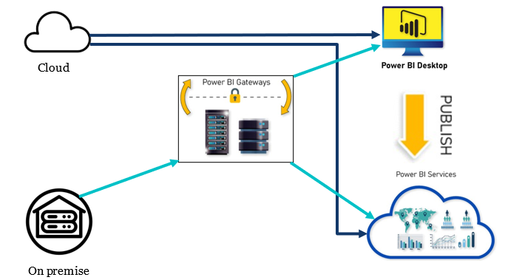

**Data Flow Chat**

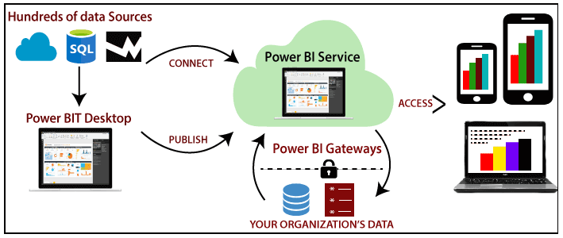

**Module designs**

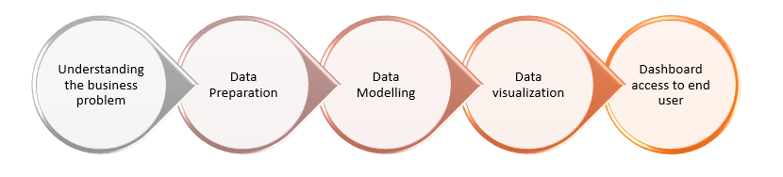

**Algorithm**

Start

* Define Project Objectives and Scope
  + Identify Data Sources
    - Collect Historical Sales Data, Return Data, and Datasets
    - Clean, Pre-process, and Integrate Data into Centralized Database
* Data Analysis and Processing
  + Identify Key Metrics and Variables
* Dashboard Development using Power BI
  + Design Dashboard Layout (Charts, Graphs, Filters)
  + Create Interactive Data Visualizations (Bar Charts, Line Graphs, Heatmaps)
  + User Access to Dashboard
  + Apply Filters, Generate Reports
* Deployment
  + Prepare, Stage, and Deploy the System
* Monitoring & Maintenance
  + Implement Ongoing Monitoring
* Regular Updates and Maintenance
* Project Closure
  + Evaluate Project Success
  + Document Outcomes
  + Seek Feedback

End

**Module information**

1. Understand the Business Problem: The business problem is to boost sales and make informed decisions in the skateboard company. Key objectives include increasing revenue, optimizing inventory, and enhancing marketing effectiveness.
2. Data Preparation: Data preparation involves cleaning, transforming, and structuring raw data to make it suitable for analysis in Power BI, ensuring data quality and consistency.
3. Data Modelling: Data modelling is the process of designing a structured framework that organizes and relates data elements to support effective analysis and visualization in Power BI. It defines how different data elements interact and form relationships.
4. Data Visualization: Data visualization is the use of graphical elements like charts and graphs to present data in a clear and understandable way, making it easier to extract insights and trends from the information.
5. Dashboard Access to End User: Dashboard access provides end users with a user-friendly interface to interact with and explore data, enabling them to gain insights and make informed decisions using the information presented in the dashboard.

**Testing Techniques and Test Plans**

* **Testing Techniques:**

Data Validation: Ensure data accuracy and completeness.

Functional Testing: Check interactive elements (e.g., filters) for correct functionality.

User Acceptance Testing (UAT): Involve stakeholders to verify requirements.

Regression Testing: Ensure changes don't affect existing functionality.

Performance Testing: Verify report responsiveness with large datasets.

Accessibility Testing: Ensure the report is usable by all users.

* **Test Plan:**

Scope: Define what will and will not be tested.

Environment: Specify testing environment (e.g., Power BI Desktop).

Test Cases: Create detailed cases for each aspect of testing.

Testing Tools: Identify tools for testing (e.g., Power BI's features).

Responsibilities: Assign roles for testing activities.

Schedule: Establish a timeline for testing phases.

Risks and Mitigation: Identify and mitigate potential risks.

Reporting: Document and communicate test results and issues.

**Result**

* Sales Trends:

We identified patterns and trends in our sales data.

* Customer Behaviour:

By analysing customer data, we discovered who our most loyal customers are and what they prefer.

* Inventory Optimization:

Monitoring our inventory levels and turnover rates helped us identify slow-moving products and optimize our inventory management.

* Marketing Effectiveness:

We evaluated the ROI of our marketing campaigns and identified which channels are most effective in driving sales. This information will guide us in allocating our marketing budget more efficiently.

* Key Insights:

Overall, our analysis provided us with actionable insights, such as which products to promote, when to run special offers, and where to focus our marketing efforts.

**Outputs**

* Final Dashboard

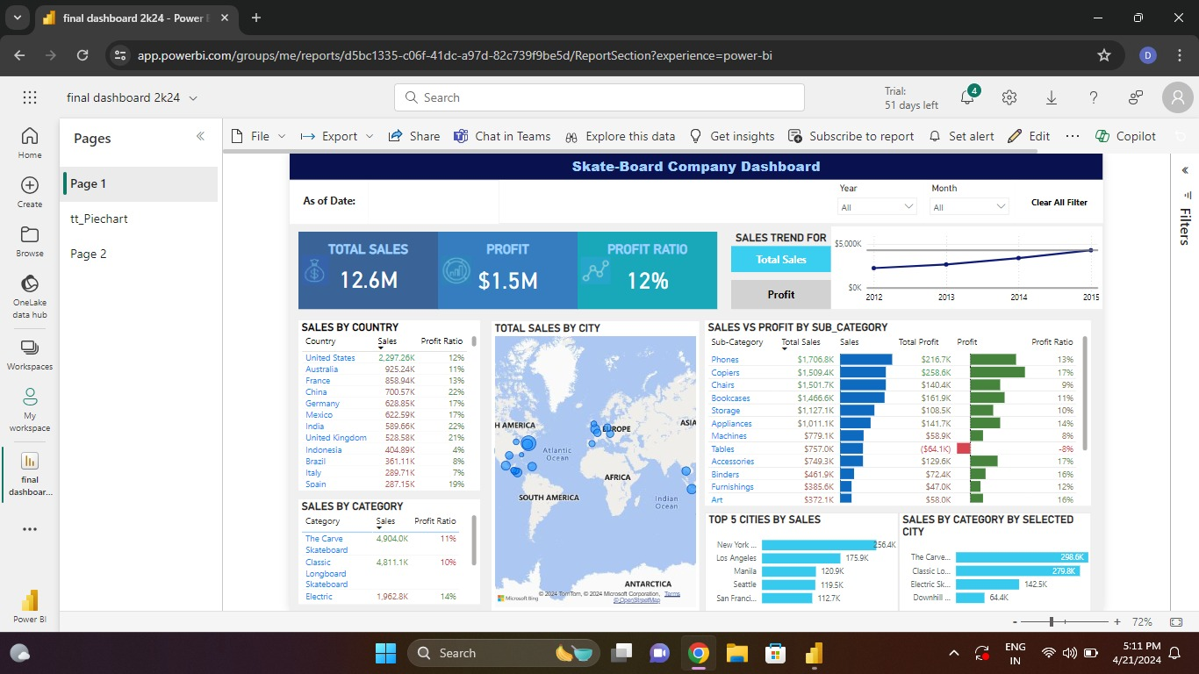

This is our final dashboard in this we have used different visuals like map, card, slicers, table, pie chart, etc.

* Slicer Visual Use

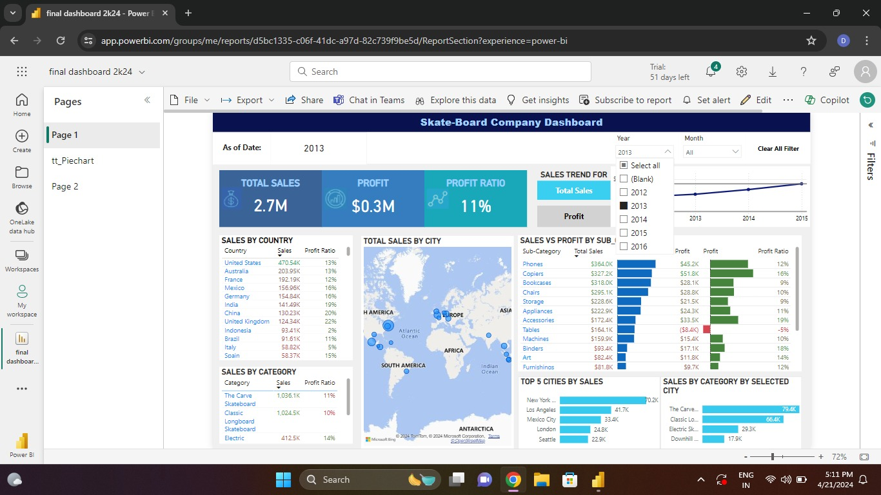

In this the results changed as we applied thee filter using slicer, we can see data of particular year or month using slicer as we can apply filters.

* Role Access

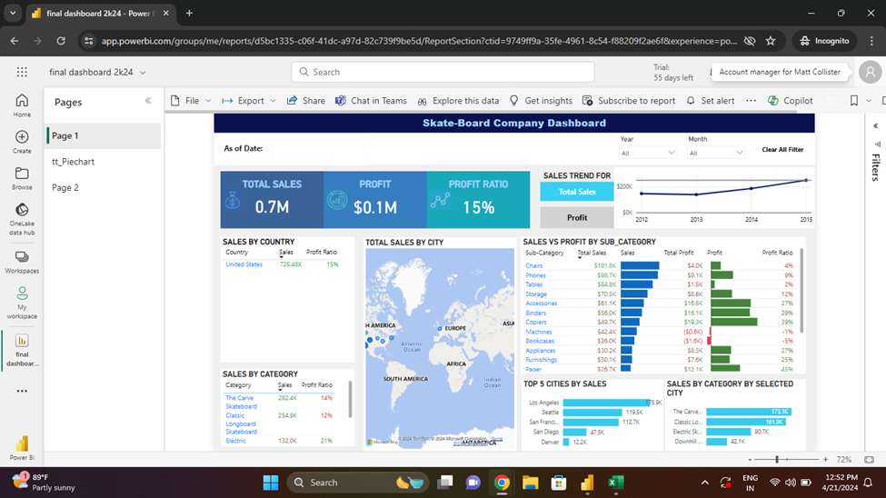

The dashboard is showing data related to united state because Matt Collister is manager of united state and we have given access to all managers with respect to the regions mentioned in people table.

* Pie Chart using ToolTip

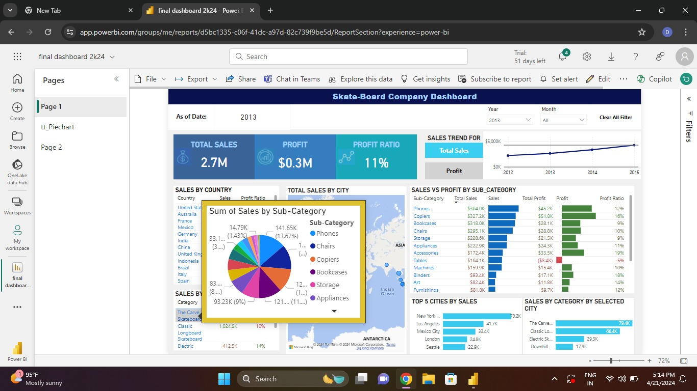

Here the pie chart shows sum of sales by subcategories it will change for every category mentioned in that table.

* Map Visual

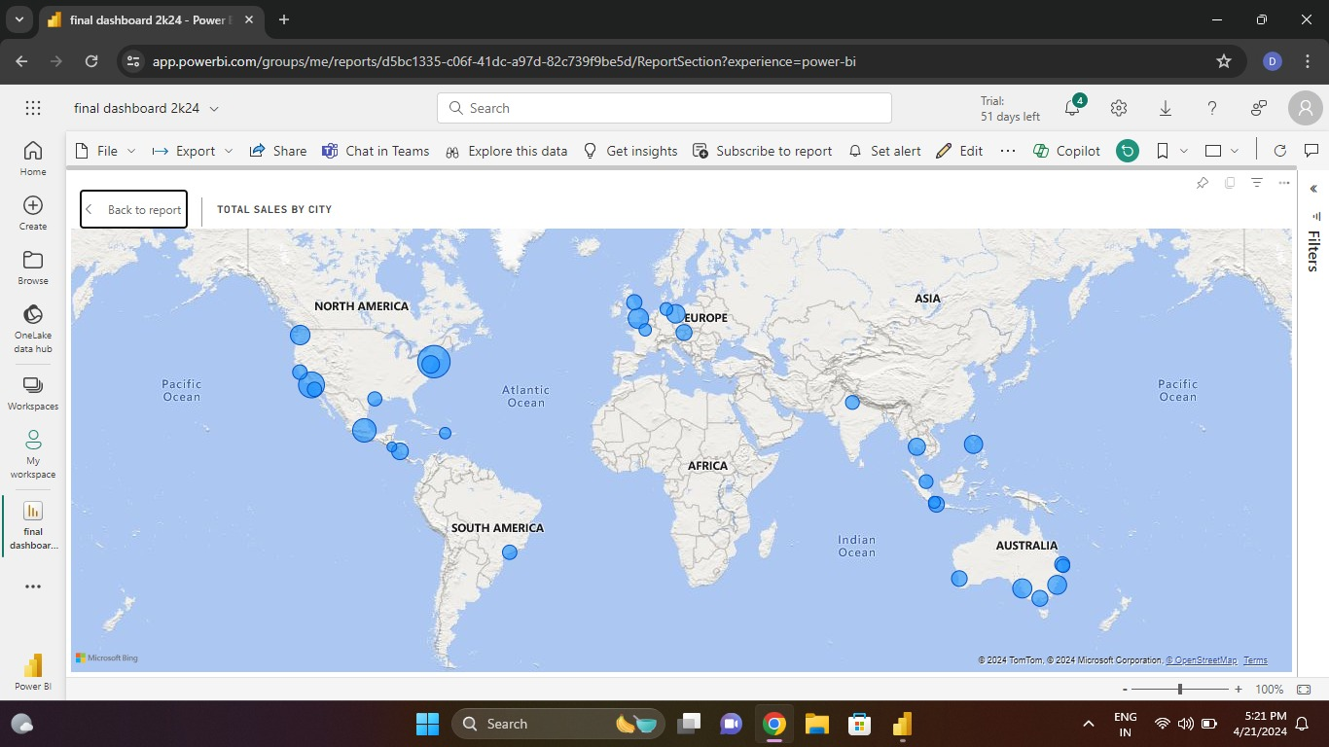

This is a map visual used to display the regional trends by the bubbles we can identify the trends by the bubble size.

**Advantages**

* Enhanced insights and analysis capabilities
* Real-time access to information for timely decision-making
* Improved efficiency and streamlined processes
* Optimization of operations and resource allocation
* Visual clarity through interactive dashboards
* Promotes collaboration and cross-functional analysis
* Empowers data-driven decision-making for business

**Disadvantage**

* Learning curve for Power BI implementation
* Potential data quality challenges
* Data privacy and security concerns
* Dependency on technology with potential technical issues
* Cost implications for implementation and maintenance

**Conclusion**

In the end, our project with Power BI was a big win for our skateboard company. We now have cool charts and graphs that tell us what's popular, who our customers are, and how to sell more skateboards. With this information, we can make better choices and keep our skateboard business rolling smoothly. It's been a success!

**Future Scope**

The future scope of the project includes:

1. Continuous Data Analysis and Monitoring: This foundation allows the company to adapt to changing market dynamics and customer behaviour, ensuring agility.

2. Expansion of Data Sources: Integration of external data sources, such as social media sentiment analysis and market research data, for a broader understanding of trends.

3. Real-Time Insights: Implementing real-time monitoring and alerts to react swiftly to emerging trends.

4. Customized Customer Experiences: Using data insights for personalized product recommendations, targeted promotions, and tailored customer service.

5. Integration with IoT Devices: Exploring IoT device integration for real-time product performance data.

6. Market Expansion: Opportunities for entering new regions or diversifying product offerings.

7. Collaboration and Partnerships: Collaborations with data analytics and technology companies for shared expertise and innovative solutions.

8. Industry Benchmarking: Benchmarking against industry standards and competitors to identify areas for improvement and innovation.

**Reference**

**Papers:**

### Title: [Data Visualization for Developing Effective Performance Dashboard with Power BI](https://ieeexplore.ieee.org/document/10100169/)

Author: [Gurpreet Singh](https://ieeexplore.ieee.org/author/37089613709); [Ankul Kumar](https://ieeexplore.ieee.org/author/37089814198); [Jaspreet Singh](https://ieeexplore.ieee.org/author/37086874865); [Jagdeep Kaur](https://ieeexplore.ieee.org/author/37089813912)

Publisher: [2023 International Conference on Innovative Data Communication Technologies and Application (ICIDCA)](https://ieeexplore.ieee.org/xpl/conhome/10099475/proceeding)

### Title: [Improving Company Performance by The Correctness of Management Decision through Implementation Dashboard using Power BI Tools (Case Study at Company Y)](https://ieeexplore.ieee.org/document/9990634/)

Author: [Ihsanul Wahyudi](https://ieeexplore.ieee.org/author/37089650579); [Yohana Dewi Lulu Widyasari](https://ieeexplore.ieee.org/author/37086516124)

Publisher[2022 8th International Conference on Education and Technology (ICET)](https://ieeexplore.ieee.org/xpl/conhome/9989534/proceeding)

**Websites:**

1. <https://data.world/datasets/skate>
2. <https://www.microsoft.com/en-us/research/project/microsoft-research-open-data/>
3. <https://www.technavio.com/report/skateboard-market-analysis>